Working procedure of Digital signature

CSE 459: Cryptography & Network Security
Submitted by
Name: D. Tejaswi
Roll No: AP22110011503
Section: CSE Y
Lab Date: 07/03/2025
Submission Date: 13/04/2025



Department Computer Science and Engineering
School of Engineering and Sciences
SRM University–AP
Amaravati, Andhra Pradesh – 522 240, India
- Question
Write a code to simulate the working procedure of digital signature by using from py_ecc.bls.ciphersuites library in multi client environment.
- Algorithm Description
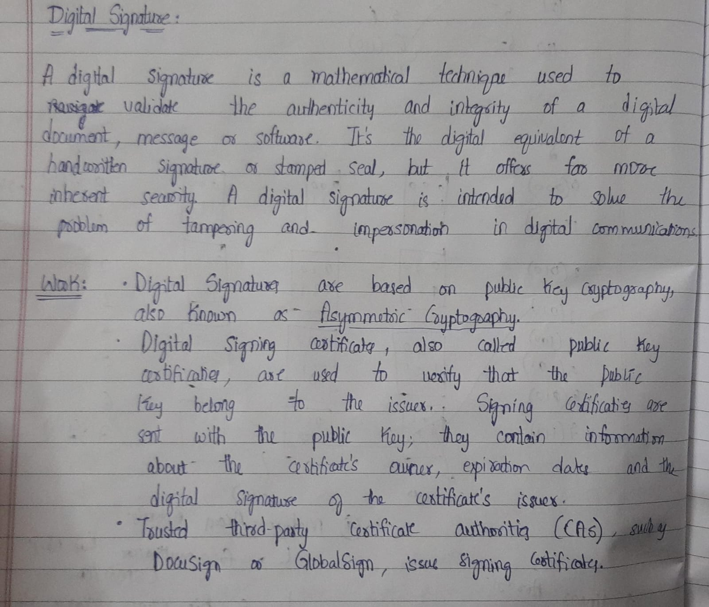

- Solution
- pip install py_ecc
- from py_ecc.bls import G2ProofOfPossession as bls
- # Simulate 3 clients
- NUM_CLIENTS = 3
- clients = {}

- # Step 1: Each client generates a private/public key pair
- for client_id in range(1, NUM_CLIENTS + 1):
- sk = bls.KeyGen(client_id.to_bytes(2, 'big')) # Simple keygen using client ID
- pk = bls.SkToPk(sk)
- clients[client_id] = {
- 'sk': sk,
- 'pk': pk
- }

- # Server maintains a list of public keys
- server_public_keys = {cid: data['pk'] for cid, data in clients.items()}

- # Step 2: Clients sign messages
- messages = {}
- signatures = {}

- print("\n--- Messages and Signatures ---")
- for client_id in clients:
- message = f"Message from Client {client_id}".encode('utf-8')
- sk = clients[client_id]['sk']
- signature = bls.Sign(sk, message)

- messages[client_id] = message
- signatures[client_id] = signature

- print(f"\nClient {client_id}")
- print(f"Message: {message.decode('utf-8')}")
- print(f"Signature: {signature.hex()}")

- # Step 3: Server verifies each signature
- print("\n--- Signature Verification ---")
- for client_id in clients:
- pk = server_public_keys[client_id]
- message = messages[client_id]
- signature = signatures[client_id]

- is_valid = bls.Verify(pk, message, signature)
- print(f"Client {client_id}: Signature is {'valid' if is_valid else 'invalid'}")
Output:
--- Messages and Signatures ---

Client 1
Message: Message from Client 1
Signature: a76dd52745d8dc093b0b85c2a191bc5444f33c475d2a0c8a588442b8b12a2b72608fff91635e58a8e059505d7c33b89d026a906ce69e48f51de15fe08c462d2efa119b17af0f2e395b1ba2f63f6ace07ae3f01d5140016e5777f913d452b25de

Client 2
Message: Message from Client 2
Signature: b84cf54e7c4bd32dc2ff659992ba88aa68dbb97326cb5aaa1526bb2da607154f09894854bcbdbadec5c4c14245243feb0b313045e0aff4842ff1fa31b1397a1c916e07b2173904c1d41291a859b5f5821d95584694bfc638f6ff5301bc6cfd0d

Client 3
Message: Message from Client 3
Signature: b6c8adab9b59d12fdd6b148369729aa39733f93fe0528e9b72fcddab72a777da34d237715aaf60162344ebb52f11af211201090f94e3e2f753a4839b72b8ca8957258effaf519722cd6c656c64dfcd8872e80e09959d5614cbef7900451ffd53

--- Signature Verification ---
Client 1: Signature is valid
Client 2: Signature is valid
Client 3: Signature is valid

- Code Repository:
https://github.com/Tejaswidarsi/Digitalsignature/blob/main/digital_signature.ipynb

